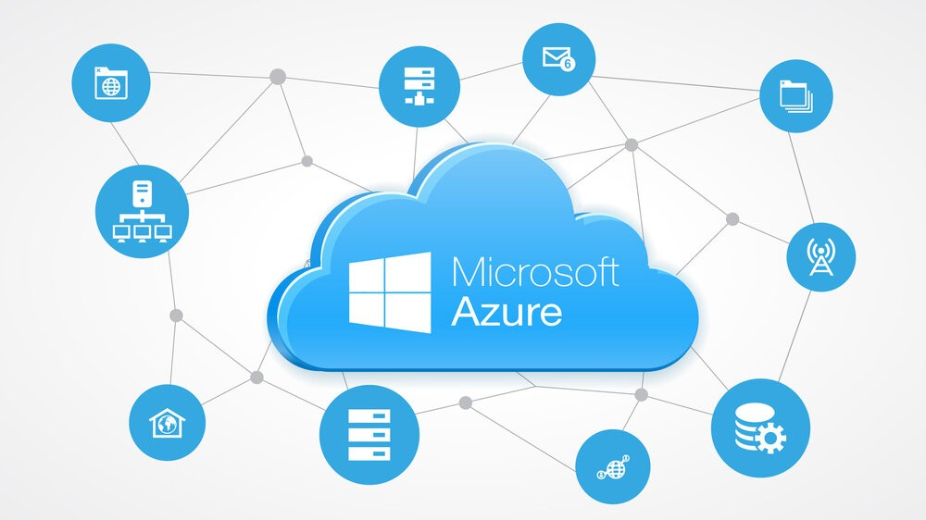

Setting Up a Virtual Machine in a Microsoft Azure Cloud Platform

Standard Operating Procedure (SOP)

14 January 2025

RECORD OF CHANGES

|  |  |  |
| --- | --- | --- |
| Date | Description of Change(s) | Author |
| 01/14/2025 | Initial Draft | Jimmie Marshall |
|  | Final revision version |  |
|  |  |  |
|  |  |  |

Table of Contents

1.0 Introduction 4

2.0 Scope 4

3.0 Prerequisites 4

4.0 Procedure 5

4.2 Navigate to the Virtual Machines Section 5

4.4 Configure Basic Settings 6

4.5 Configure Disks 6

4.6 Configure Networking 6

4.7 Management Settings 7

4.8 Review and Create 7

4.9 Monitor Deployment 7

4.10 Pos-Deployment Configuration 7

5.0 Troubleshooting 7

6.0 Roles and Responsibilities 8

References 8

# 1.0 Introduction

This Standard Operating Procedure (SOP) provides step-by-step instructions for creating and configuring a virtual machine (VM) in Microsoft Azure. The goal is to ensure consistency, reliability, and security during the VM setup process.

# 2.0 Scope

This procedure applies to all IT administrators, cloud engineers, and personnel tasked with creating and managing Azure virtual machines within the organization’s cloud infrastructure.

# 3.0 Prerequisites

1. Access to the Azure Portal with the necessary permissions (e.g., Contributor or higher role).

2. An existing Azure subscription.

3. Basic knowledge of virtual machines and networking concepts.

4. A pre-determined resource group, region, and virtual network configuration (if applicable).

# 4.0 Procedure

4.1 Log in to the Azure Portal

1. Navigate to  [https://portal.azure.com](https://portal.azure.com/).

2. Enter your credentials (username and password) and complete any multi-factor authentication (MFA) prompts if enabled.

## 4.2 Navigate to the Virtual Machines Section

1. In the Azure Portal homepage, select “Virtual Machines” from the left-hand menu.

• If not visible, use the search bar to locate “Virtual Machines”.

4.3 Create a New Virtual Machine

1. Click the “+ Create” button at the top of the Virtual Machines page.

2. From the dropdown, select “Azure Virtual Machine”.

## 4.4 Configure Basic Settings

## 1. On the “Basics” tab, provide the following details:

## • Subscription: Select your Azure subscription.

## • Resource Group: Choose an existing resource group or create a new one.

## • Virtual Machine Name: Enter a unique name for the VM (e.g., Prod-VM01).

## • Region: Select the region where the VM will be deployed (e.g., East US).

## • Availability Options: Choose the desired availability option (e.g., Availability Zone or Availability Set).

## • Image: Select the operating system image (e.g., Windows Server 2022 or Ubuntu 20.04).

## • Size: Click “Change Size” and select the appropriate VM size based on performance needs.

## 2. Configure Administrator Account:

## • For Windows: Set a username and password.

## • For Linux: Set a username and upload an SSH public key or set a password.

## 3. Set Inbound Port Rules:

## • Open necessary ports (e.g., RDP for Windows, SSH for Linux).

## • Select “Allow selected ports” and choose from the dropdown (e.g., SSH (22) or RDP (3389)).

## 4.5 Configure Disks

## 1. On the “Disks” tab, select the storage type:

## • OS Disk Type: Choose Standard SSD, Premium SSD, or Standard HDD.

## • Data Disks: Add additional disks if needed by clicking “+ Create and Attach a New Disk”.

## 4.6 Configure Networking

## 1. On the “Networking” tab, ensure the following:

## • Virtual Network: Select an existing virtual network or create a new one.

## • Subnet: Assign a subnet within the virtual network.

## • Public IP: Configure a new public IP or use an existing one.

## • NIC Network Security Group (NSG): Choose Basic or Advanced to configure inbound/outbound rules.

## 4.7 Management Settings

1. On the “Management” tab, configure:

• Monitoring: Enable boot diagnostics and Azure Monitor if required.

• Identity: Assign a managed identity for the VM if needed.

## 4.8 Review and Create

1. Review the configurations on the “Review + Create” tab.

2. Ensure there are no validation errors.

3. Click “Create” to start provisioning the virtual machine.

## 4.9 Monitor Deployment

1. In the Azure Portal, monitor the deployment process from the Notifications pane.

2. Once the deployment is complete, navigate to the Virtual Machines page and verify the VM’s status as “Running”.

## 4.10 Pos-Deployment Configuration

1. Access the VM:

• For Windows: Use Remote Desktop Protocol (RDP) with the public IP and credentials.

• For Linux: Use SSH with the public IP and credentials/keys.

2. Update the Operating System:

• For Windows: Run Windows Update.

• For Linux: Use the appropriate package manager (e.g., sudo apt update && sudo apt upgrade).

3. Install Required Applications: Install any necessary software or tools based on the VM’s purpose.

4. Apply Security Policies:

• Configure firewall settings and security baselines.

• Disable unnecessary services and protocols.

# 5.0 Troubleshooting

• Issue: Deployment validation errors.

• Solution: Review and correct settings on the Review + Create tab.

• Issue: Unable to connect to the VM.

• Solution: Verify NSG rules, open necessary ports, and check network connectivity.

• Issue: VM is not starting.

• Solution: Check the Azure Activity Log for errors or attempt a restart.

# 6.0 Roles and Responsibilities

• Cloud Administrator: Responsible for configuring and managing the virtual machine.

• Security Officer: Ensures compliance with security guidelines.

• Reviewer/Approver: Verifies that the setup meets organizational requirements.

# References

• [Azure Virtual Machines Documentation](https://learn.microsoft.com/en-us/azure/virtual-machines/)

• [Azure Networking Best Practices](https://learn.microsoft.com/en-us/azure/architecture/best-practices/network-security/)